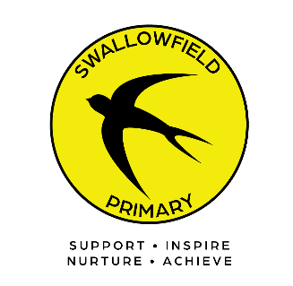
Swallowfield Primary

Weathercock Close, Woburn Sands, Milton Keynes, MK17 8SR, Tel: 01908 582101

Monday 6th July 2026

Dear Parents/Carers,

Welcome to Year 3! We are so pleased to be welcoming you back and having all the children at school. We hope that you had a restful summer break and that the children are looking forward to the new school year. Our theme this half term will be ‘The Stone Age’. An overview of all of our learning will be available on the school website shortly along with some helpful knowledge organisers. We hope the children will really enjoy this theme and find it to be an interesting and exciting learning experience.

Homework
Homework will recommence the week beginning 11th September. The Autumn terms break down of homework will be stuck inside your child’s learning log, we ask that you sign off the children’s daily reads as well as any completed homework tasks. The children will continue to receive weekly spellings on a Monday and will be tested on Friday. We will also be practising our times tables every week and may send home some ideas and ways to practise these too. It is very important that the children practise both of these at home on a daily basis to support their learning in class.
We will recommence the Home/School library in the second week of term and look forward to offering the children the opportunity to take a reading book home on a regular basis. The children will be required to borrow and return their books each week on a Thursday. We encourage all of the children to read with an adult on a daily basis. If they haven’t done so already, please ensure that your child has returned their book bag from the previous year.

Any completed homework should be submitted via your child’s learning log. Photographs or short video clips can however be sent to your child’s class teacher via google classrooms .It will not be necessary to submit spelling practice. We understand that it is sometimes difficult to find time for the children to complete their Learning Tasks, but we do encourage them to complete at least one piece a week. This enriches and supports their work at school.

Equipment
Please ensure your child brings a named water bottle to school every day and an optional morning fruit snack. We ask that the children only have water in their bottles please. The children can also bring in one book from home that they can read during ERIC time. In addition, they will need their own pencil case. Please refer to the school website for details of the size and contents of the pencil case. https://swallowfieldprimary.com/wpcontent/uploads/2023/08/year5and6equipment_20230718172000181.pdf

P.E
P.E. day is Thursday for both classes. This term we will be Swimming and learning a new game called ‘Quicksticks’ (an age appropriate version of hockey). As you can imagine, we will try to be outside for these as much as possible. We ask that the children come into school wearing their weather appropriate PE kits on the day that they are doing PE. Children will also need to bring in their swimming kit on their designated swimming day. Please see below for each class.

Mrs Knox & Miss Darvill (YDK) – Acacia swim Wednesday and PE Thursday
Miss West (Y3W) – Kapok swim Monday and PE Thursday

Please be aware that we will not be able to provide spare kit. PE and swimming are a statutory part of the KS2 curriculum and therefore children are required to take part if they are in school. We would also like to remind you that children are not allowed to wear earrings or jewellery during P.E.

Contact
Please use email to communicate with your child’s class teacher. Teachers will respond to emails within 48 working hours. If the matter is urgent please telephone the school office. (01908 582101)

k.knox@swallowfieldprimary.com
g.darvill@swallowfieldprimary.com
a.west@swallowfieldprimary.com

We are looking forward to a very exciting and successful year.

Mrs Knox, Miss Darvill and Miss West

