Swallowfield
Busy Bees Pre-School
Prospectus

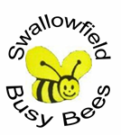
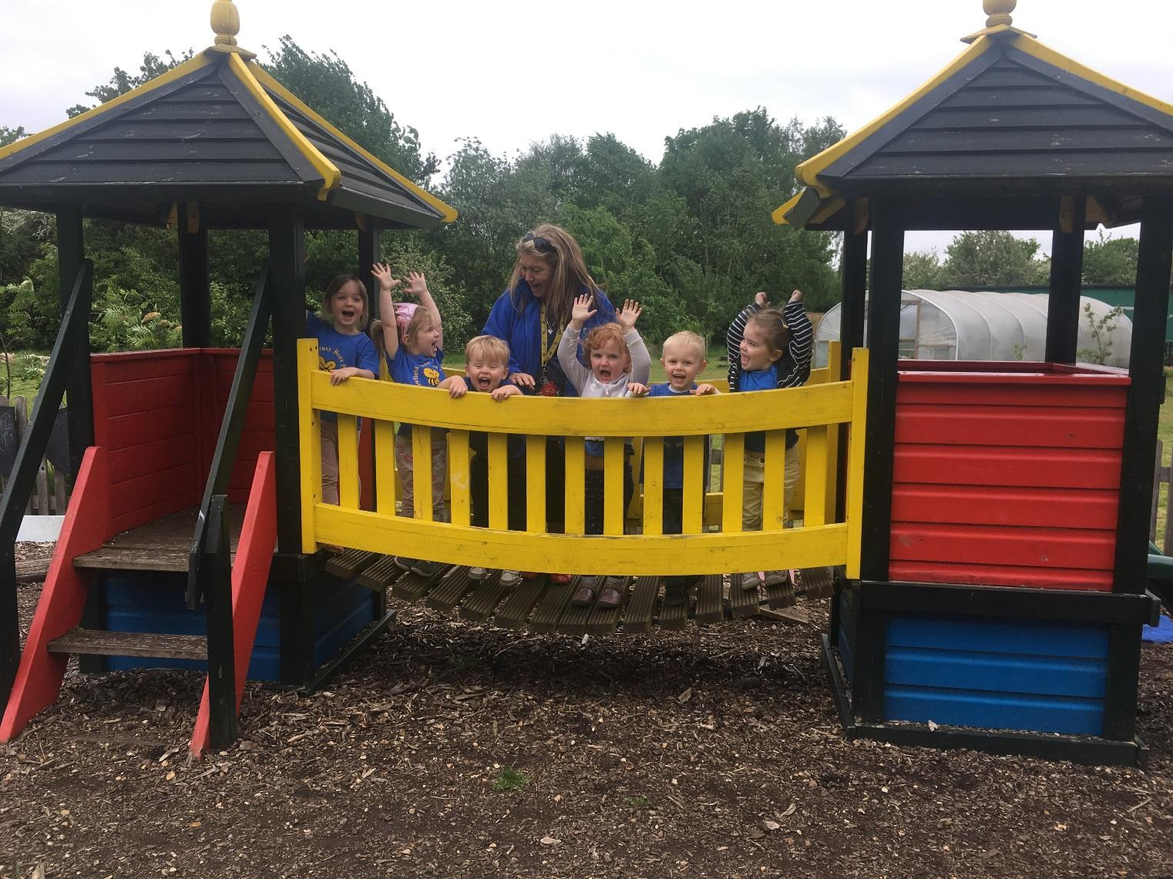

enquiries@swallowfieldprimary.com or busybees@swallowfieldprimary.com
WELCOME

We hope you find the following information about Swallowfield Busy Bees Pre-School helpful and informative. Please visit or contact us for further information.

Swallowfield Busy Bees is your local pre-school and has been established for over 30 years. It is fully integrated into the main school and positively supports the transition into Swallowfield Lower School. (Please see our transition information further in this brochure). We are an inclusive setting and welcome all children aged 2 years until they start school at 4+. Most children move from Busy Bees to Swallowfield Lower School (please contact the school direct for their admissions policy). We are very proud of our OFSTED inspection reports, which are available upon request or from our website enquiries@swallowfieldprimary.com

Central Bedfordshire’s Childcare Development Team and their Early Years Advisory team support Swallowfield Busy Bees.

Overarching Principles
Six guiding principles shape our practice at Swallowfield Busy Bees.
These are:
- Every child is a unique child who is constantly learning and can be resilient, capable, confident and self-assured.
- Children learn to be strong and independent through positive relationships.
- Children learn and develop well in enabling environments, in which their experiences respond to their individual needs and there is a strong partnership between practitioners and parents and/or carers; and
- Children develop and learn in different ways and at different rates. The framework we follow covers the education and care of all children in Early Years Provision, including children with special educational needs and disabilities.
- We promote equality and respect diversity.
- We are a values school. We help to promote the spiritual, moral, social and cultural development of all pupils at Busy Bees.

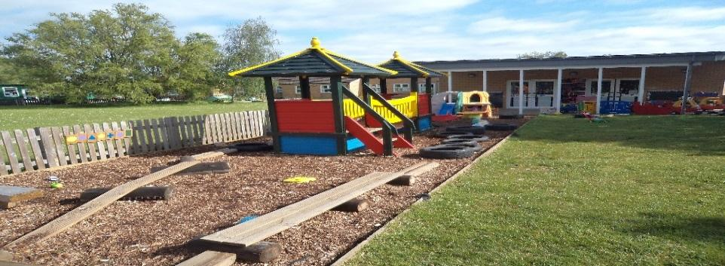

Areas of Learning and Development
There are seven areas of learning and development that shape our educational programmes. All areas of learning and development are important and inter-connected. Three areas are particularly crucial for igniting children’s curiosity and enthusiasm for learning, and for building their capacity to learn, form relationships and thrive. The three prime areas are:

Communication and language.
Listening and attention and understanding
Speaking

Physical development
Gross Motor skills
Fine Motor skills

Personal, social and emotional development.
Self-Regulation
Managing Self
Building Relationships

A wide range of activities are provided at each session to support these areas. Our activities include clay, cooking, construction, dough, drawing, jigsaws, mark making, music, painting, sand and water play, dressing up, home corner stories, and so much more. We aim to provide a wide breadth of experience during the week and organise themed projects so that children can bring items to show and talk about, therefore forming a stronger link between home and pre-school.

We also encourage the children to develop key skills in specific areas, these areas are :

Literacy;
- Comprehension
- Word Reading
- Writing

- Mathematics;
- Numbers
- Numerical patterns

- Understanding the World;
- Past and Present
- People, Culture and Communities
- Natural World

- Expressive Arts and Design.
- Creating with materials
- Being imaginative and expressive

Our Approach to Learning and Development and Assessment.

Learning Through Play.
By immersing themselves in play and engaging in conversation, young children gain new knowledge and develop their cognitive abilities—a method widely recognised by research as essential for early education. In our environment, we provide a broad range of play experiences that foster development in every area of learning. Children are encouraged to explore and choose activities independently, while at other times, adults offer support and encouragement to help them participate. Each play session is thoughtfully organised, drawing on the Early Years Foundation Stage framework to select suitable resources and approaches, ensuring activities reflect both the children’s interests and developmental needs.

Assessment
We regularly observe each child to keep track of their learning and development. Using the information we gather from these observations—along with photos and videos—we document their progress and plan appropriate next steps to support their ongoing learning journey.
At specific times throughout the year, and when children experience significant changes—such as moving up to Reception—we create summary reports that showcase their accomplishments. These reports are based on our continuous records and our understanding of the child, and they form an important part of each child's learning journal.

2/3 Year Development Reviews
The Early Years Foundation Stage requires that we supply parents and carers with a short summary of their child’s development in the three prime learning and development areas of the EYFS before their child is 36months. The child’s key worker completes the check using information from their observations and information gathered over time. This takes place at the setting the child attends during sessions and parents will be invited to attend a short meeting to discuss the review.

Learning Journals
We maintain records of each child’s special achievements, known as ‘wow moments’, allowing us to celebrate successes and collaborate to support your child’s well-being and development. You’ll have opportunities to discuss your child’s progress with their key worker, including parent consultations and meetings. If you have any concerns or queries about your child, please ask to speak with a member of staff at any time. Parents are also welcome to view their child’s journal throughout the term. In addition, Busy Bees uses the online journal Seesaw, which enables us to share real-time observations with you for immediate viewing.

Key Workers and Your Child
At Busy Bees, we operate a Key Worker system, whereby staff take responsibility for a specific group of children. Your child’s Key Worker will collaborate with you to ensure our provision is tailored to meet your child’s unique requirements and interests. From their very first days at Busy Bees, the Key Worker will support your child as they settle in and will continue to assist them throughout their time here, helping them to make the most of all the activities and opportunities our setting offers.

The Session
We organise our sessions so that the children can choose from and work at, a range of activities and in doing so, build up their ability to select and work through a task to its completion. The children are also helped and encouraged to take part in adult-led small and large group activities which introduce them to new experiences and help them to gain new skills, as well as helping them to learn to work with others.
We aim to build children's confidence and independence during their time at pre-school, encouraging them to try new activities and make choices for themselves. By fostering a supportive and caring environment, we help each child to develop a positive sense of self and to approach new challenges with enthusiasm.

Outdoor Activities
Taking part in outdoor activities supports every aspect of children's growth, with a particular focus on their health and physical abilities. Children are given plenty of chances and are actively encouraged to join in both self-selected outdoor play and adult-guided activities, alongside those on offer in the indoor classroom.

Snacks and Meals
We treat snack and mealtimes as enjoyable social occasions where children and staff come together. Please let us know if your child has any specific dietary requirements, and we will ensure these are fully accommodated.
At lunchtime, your child has the option to enjoy either a packed lunch, which you provide, or a hot meal from the school, available for an additional charge. All children dine together in the main school dining hall and are accompanied by staff, who walk with them to the dining area and stay throughout the meal, helping as needed until everyone has finished eating and is ready to return to Busy Bees.

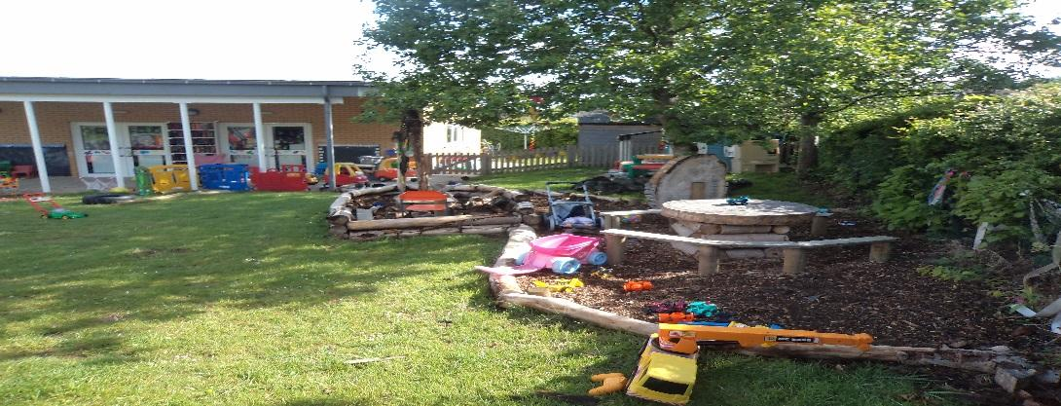

Safeguarding Children
Busy Bees has a duty under the law to help safeguard children against suspected or actual ‘significant harm’. All staff members have had training in Safeguarding Children.

Special Needs Support
Busy Bees complies with the requirements of the 1993 Education Act and abides by the principles set out in the Special Educational Needs Code of Practice (2001). Mrs Millward serves as the Special Needs Co-ordinator for Swallowfield Primary, while at Busy Bees, Avril MacKenzie provides support for children with special needs, in collaboration with Mrs Millward.

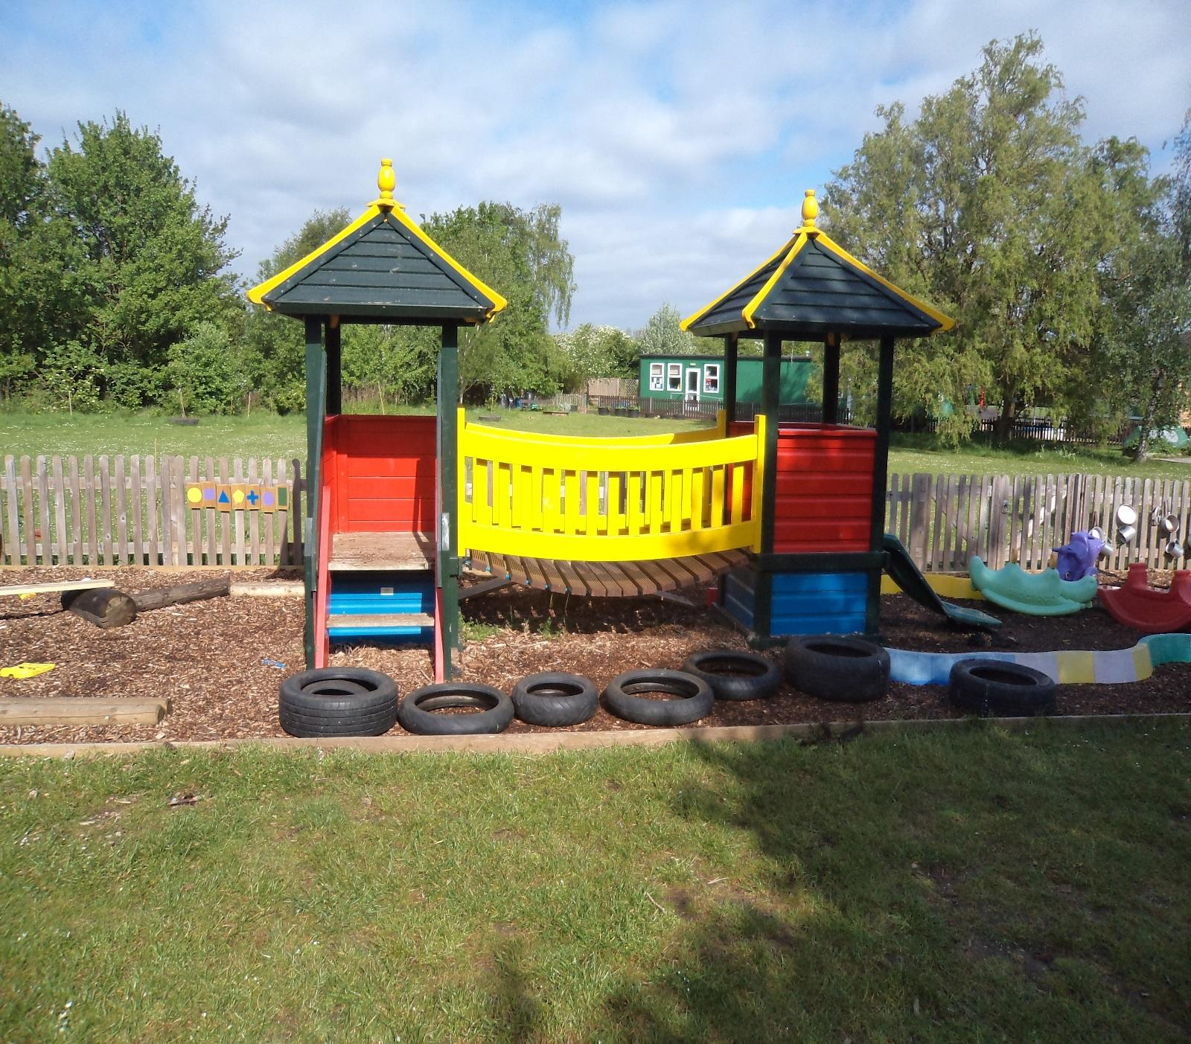
Busy Bees Staff

Kim Bishop Manager L4
Sarah Lynch Deputy Manager L3
Avril Mackenzie Early Years Practitioner L3
Sarah Boulton Early Years Practitioner L3
Alison Chong Early Years Practitioner L2
Andrea Ballabas Classroom Assistant

Every keyworker has received thorough training across various aspects, including child development. Staff members regularly participate in additional courses as needed. Staff hold recognised qualifications in first aid and food hygiene. The Manager and team maintain staff-to-child ratios as follows: one adult for every eight children aged over three years, and one adult for every four children under three years old.
Busy Bees Preschool has twice been awarded the Central Bedfordshire Communication Friendly Setting Award and offers the Lift Off to Language Programme to children aged two, as well as those aged three and four.

Opening and Closing Times
We are open for 38 weeks a year and closed for school holidays and inset days. (See Swallowfield School website for dates).

Daily Sessions
Morning Sessions
8.50am – 11.45am
Lunch Club
11.45am – 12.15pm
Afternoon Sessions
12.15pm – 3.20pm

Pre-Reception Sessions
Pre-Reception sessions take place on two afternoons and are designed specifically for children who will be starting school in September. These sessions provide an early experience of Reception, helping to ease the transition and prepare children for joining Reception the following year. Swallowfield School Reception Teachers and Busy Bees staff lead these sessions, and they have consistently shown positive results. Children who already attend afternoon sessions will automatically be offered a place for one of these sessions, subject to availability. On these afternoons, standard pre-school sessions continue to be available for younger children.
Attending Busy Bees / Pre Reception sessions does not guarantee your child a place at Swallowfield Primary, applications online for school places are decided by the local authority inline with the criteria for that school.
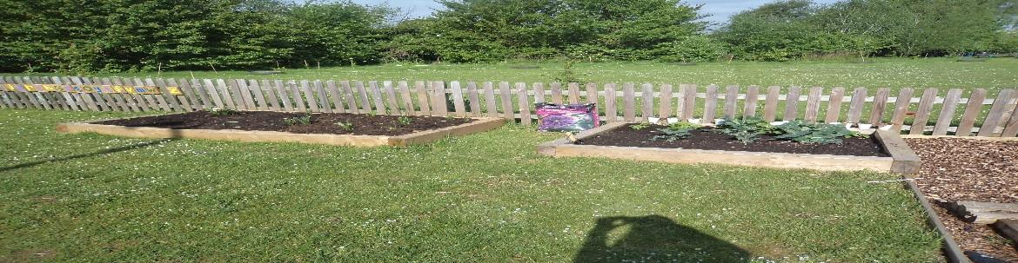
Admissions
Swallowfield Busy Bees is promoted within the local area and follows the admissions policy when allocating spaces, which can be found at the end of this prospectus.
Our aim is to ensure your child feels comfortable and secure at Busy Bees. Before your child starts, we will invite you both for a short introductory visit, giving you the opportunity to meet your child’s key worker and other staff members. During this visit, we will talk about any particular needs or preferences your child may have and discuss the best ways to help them settle into pre-school. We will also explain our policies and answer any questions you might have.

Clothing

Busy Bees T-shirts are to be worn to sessions and one is included in the price of your administration fee. Sweat shirts and additional t-shirts are available from: - swallowfield@mswsolutions.com. A link to this site is available on our main school website.

We provide protective clothing for the children when they play with messy activities. We encourage children to gain the skills that help them to be independent and look after themselves.
Clothing that is easy for them to manage with help them to do this, especially during toilet training when children need to be able to manage their clothing, leggings rather than dungaree’s etc.

- Please name all shoes, coats, jumpers and bags (no carrier bags please). Spare items of clothing are kept at Busy Bees in case of spills or accidents.

Arrival and Departure from Busy Bees
Parents should wait outside the main gate before Busy Bees opens. Once your child is comfortable and settled into Busy Bees, please encourage them to enter the gate independently as this boosts their confidence and self-reliance during the morning drop-off.
At the end of each session, children will be handed directly to parents; kindly remain outside the Busy Bees gate until a staff member brings your child out.
If someone else will be picking up your child, please inform the Manager or a staff member in advance. Should you encounter any difficulties reaching Busy Bees, rest assured your child will be supervised by two staff members until you arrive – it is essential that we have an emergency contact number for every session.

In the event of Illness
Kindly ensure you complete a day care form with all relevant emergency contact details we might require should your child become unwell, enabling us to reach you promptly if needed. We also request that you notify us if your child contracts any infectious illness.
Please adhere to recommended isolation periods both during and following any contagious diseases.
In the event of sickness involving vomiting or diarrhoea, your child should remain at home for 48 hours after the last episode to help prevent the spread of infection. Please note that fees are still payable for all sessions, regardless of attendance. If your child is unwell, contact the school office on 01908 582101 as early as possible on the first day of absence.

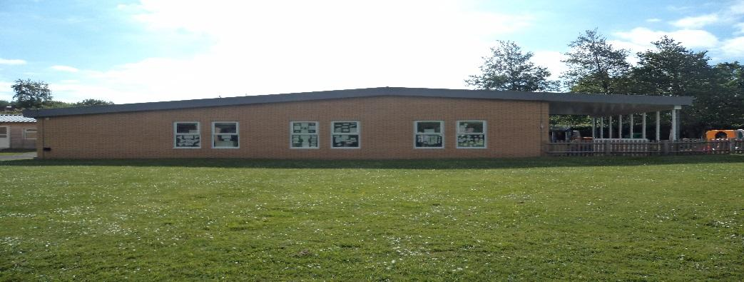

Health and Safety

Toileting and personal care
Children are free to use the toilet whenever they wish, either independently or with assistance from a staff member.
Facilities such as a potty, a step, and a toilet seat are available to cater for different needs, so please inform your key worker if your child has any preferences. It’s understood that not every child will be fully toilet trained upon starting at Busy Bees, and accidents are expected as part of the training process. Staff approach these situations with understanding and kindness; no child will be reprimanded for such incidents, and staff will help your child change when needed.
If you are in the process of toilet training your child, please let the staff know – they will support and encourage your child’s independence both at pre-school and at home. Handwashing is promoted, with sinks and hand dryers installed at a child-friendly height. Kindly provide nappies and wipes for your child; staff will let you know when more supplies are needed.

Accidents
All accidents and incidents are carefully documented using our online Medical Tracker system. If your child experiences a minor mishap during their time at pre-school, it will be logged and you’ll receive notification via email from Medical Tracker. Please check that your contact details on the day care forms are up to date. Busy Bees staff hold appropriate first aid qualifications. Should your child sustain an injury or have an accident prior to arriving at Busy Bees, kindly inform a staff member when you drop them off.

Fees
Our fees are set at a fair rate to cover staffing and general running costs. You will receive an invoice for fees payable.
A one-off, non-refundable administration fee of £15.00 is payable when registering your child at Busy Bees. Please ensure you bring your child’s birth certificate along at registration.
The fee for each session is £20.50 (Sept 26), up until your child qualifies for government funding (from the term after their third birthday). Lunch care is charged at £4.50 per session. Fees can be paid by cash, cheque, or childcare vouchers to the Administration Team at the Main School Office.
PLEASE NOTE: The Lunch Care charge does not include the cost of a hot dinner, should your child have one. Payment for hot dinners will be managed separately by Parent Pay, and you will be provided with an account to pay for your child’s meals.
Please see our Fees Policy on the Swallowfield Website.

Nursery Education Grant
Swallowfield Busy Bees accepts the Governments’ Nursery Education Grant for 3- and 4-year-olds. Your child will not be eligible until the term after they are 3 years old. Some children may also be eligible for free sessions from 2 years old. (See your local council website for details). You may also be eligible for the 30 hours funding from the Government. You will need to apply online and obtain a code which we will require.

https://www.gov.uk/help-with-childcare-costs/free-childcare-2-year-olds-extra-support

https://www.gov.uk/help-with-childcare-costs/free-childcare-and-education-for-3-to-4-year-olds

https://www.gov.uk/free-childcare-if-working

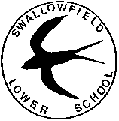
Weathercock Close, Woburn Sands, Milton Keynes, MK17 8SR
Incorporating Busy Bees Pre-School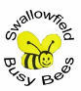

Admissions Policy

It is our intention to make our pre-school genuinely accessible to children and families from all sections of the local community. In order to accomplish this, we will:

- Ensure that the existence of the pre-school is widely known in all local communities. We will place notices advertising the pre-school in places where all sections of the community can see them.
- Arrange our waiting list in order of school year start date i.e., those children due to start school the following September will be given priority.
- Keep a place vacant, if this is financially viable, in order to accommodate emergency admissions.
- Describe the pre-school and its practises in terms which make it clear that it welcomes both fathers and mothers, other relations and other carers, including childminders, and people from all cultural, ethic religious and social groups, with and without disabilities.
- Monitor the gender and ethnic background of children joining the group to ensure that no accidental discrimination is taking place.
- Make our equal opportunities policy widely known.
- Parents will be assured that the staff are always happy to listen and help should any problems arise with their child and that any concerns will be dealt with confidentially.
- Home school books keep parents informed of children’s development and activities and also offer parents an ideal opportunity for communication.

In line with the principles stated above, and Swallowfield Lower Schools’ admission policy, the following criteria will be applied to all applicants with priority given based on the date the request was received:

- Looked After Children;
- To brothers and sisters of pupils currently attending the school and living in the schools catchment area;
- Other children living within the school catchment area;
- To siblings of existing pupils living outside the catchment area;
- Other children;
- We keep a place vacant, if this is financially viable, to accommodate an emergency admission.
NB: Any variance to this admission criterion will be at the discretion of the Senior Leadership Team.
Settling In
We want our children to feel safe and happy in the absence of their parents, to recognise other adults as a source of authority, help and friendship and to be able to share with their parents afterwards the new learning experiences enjoyed in the pre-school.

In order to accomplish this, we will:
- Arrange for the child to have a visit to the pre-school. This visit will take place before the child is due to start.
- Make clear to families from the outset that they will be supported in the pre-school for as long as it takes to settle their child there.
- Reassure parents whose children seem to be taking a long time settling into the Pre-school.
- Introduce new families into the group on a staggered basis, for example two new children each day for a week rather than ten new children all at once.
Children cannot play or learn successfully if they are anxious and unhappy. Our settling procedures aim to help parents to help their children to feel comfortable in the pre-school, to benefit from what it has to offer, and to be confident that their parents will return at the end of the session.

Payment Policy
All fees are payable in advance. Payment to be received within 14 days of invoice being issued and Cheque, Cash or Childcare Vouchers are accepted. In the event of emergency closures session or sickness absence fees still apply.

If you are having difficulty making your payments, you should speak to the office as soon as possible so that we can discuss with you the options available. For the sake of the child we make every effort to come to an arrangement with you to pay off the debt, but if no agreement is made, or you do not keep to it, we may have to withdraw your child's place at the school and hand the debt over to a recovery agency.

Fee Policy

There are five morning sessions and five afternoon sessions. In allocating sessions, the administrator will ensure that we are able to offer thirty-two places in any one session and of those 32 children a maximum of 8 will be under 3.

Half a term’s notice is required if you wish to terminate your child’s place.
However where possible changes to sessions can be made sooner.
In allocating sessions within each criterion the administrator will consider preferences detailed on the registration form but it should be noted that preferences cannot be guaranteed.

A minimum of two sessions per week is mandatory as this is beneficial to the child.

Parents or guardians are always invited to visit us, before their child starts officially and whilst a session is in progress. Subsequent visits are welcome at any time.

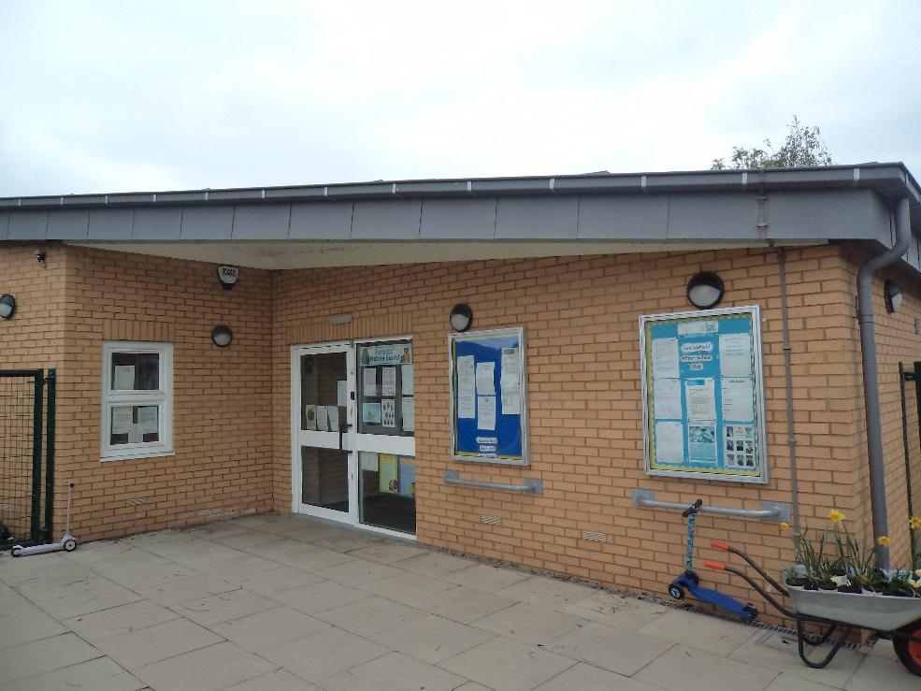

Swallowfield Primary School
Weathercock Close
Woburn Sands
Milton Keynes
MK17 8SR

Tel: 01908 582101
enquiries@swallowfieldprimary.com

busybees@swallowfieldprimary.com

