[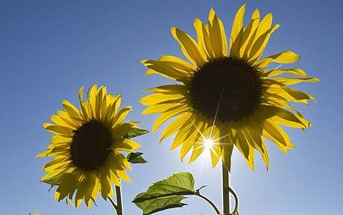](http://www.google.co.uk/url?sa=i&source=imgres&cd=&cad=rja&uact=8&ved=0CAwQjRwwAA&url=http://www.telegraph.co.uk/gardening/howtogrow/5540994/How-to-grow-sunflowers.html&ei=-5xsVZyNGaSM7AahtoGIBA&psig=AFQjCNF2ymxhJ-2aMNCUcIOYYRFAVN_Ciw&ust=1433267835495311)**Sunflower Growing 2020**

**A long term challenge for the whole family!**

As a means of getting everyone growing, at home and at school, despite difficult circumstances this year, we would like everyone to get involved in our annual sunflower growing challenge! This year we are also joining up with the wider community, with the aim of getting everywhere looking bright and sunny into the autumn with a great display of sunflowers!

We would like you to have a go at growing your own sunflower/s, keep a visual and written record of how they are doing, and when they have flowered, measure their height and if possible the size of the flower.

Then send the measurements and any pictures in and we will have a competition to see who has grown the largest!

Watch out too for competitions for the Community Challenge and a range of activities being planned for the autumn around the theme of sunflowers!

**Aims of activity** - To encourage children and families to use the outdoors, engage in growing things for themselves, finding out what a plant needs for growth, life cycles and taking care of living things.

To develop a sense of community by joining in with something taking place in the wider community.

[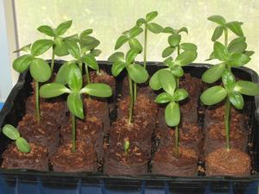](http://www.google.co.uk/url?sa=i&source=imgres&cd=&cad=rja&uact=8&ved=0CAwQjRwwAA&url=http://pixshark.com/sunflower-seeds-growing.htm&ei=Qp1sVeW2K-m67gb754CACA&psig=AFQjCNElo40J089cINq6FcB39ktM5X-Z9A&ust=1433267906810872)

*Step 1* Get hold of some sunflower seeds or seedling plants.

*Step 2* Find something to grow them in - any container will do, you could make paper pots, egg boxes, yogurt pots and food trays keep it ‘eco’. Whilst potting compost speeds growth up once growth starts, to start the seeds off, homemade compost, soil, sand and even tissue will be fine for a short while.

*Step 3* Make a little hole in the top, pop the seed in, on its side is better (or a few holes and seeds). Keep it watered and warm and watch for growth.

*Step* 4 Once the second set of leaves (‘true’ leaves rather than ‘seed’ leaves.) have appeared, depending on what you started them in, they may need potting on into compost or soil. Probably still into a pot/container is best at this point.

*Step 5* Let them grow on a little more, they will quickly need a small stake and thin string to tie them to gently support them though. Watch out for frosty nights, but soon …

*Step 6* It should be warm enough for them to go outside if you wish, though following a “hardening off” process will mean their growth is not slowed down. For this, simply put the pot out during the day, then indoors or under shelter at night for a week or so. Once outside, keep an eye open for slugs, snails and aphids, they love the soft plants!

[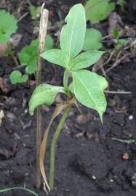](http://www.google.co.uk/url?sa=i&source=imgres&cd=&cad=rja&uact=8&ved=0CAwQjRwwAA&url=http://randsco.com/index.php/2006/06/23/sunflower_project&ei=Ip1sVa33DfLW7QbnroLoCQ&psig=AFQjCNGaeCJ9HnISqDVX1kvZ5OvMZZVgTw&ust=1433267874312047)As they grow, they may need watering every day and will soon use up all the available food and space for roots if still in a pot/container.

*Step 7* **Transplanting the Sunflower**

(When roots start to come out of the bottom of the pot, it keeps wilting and you

find it needs water more than once a day!)

The plant could now be transplanted into increasingly bigger pots,

each time it outgrows one. Or you could decide it’s ready for it’s final home.

**Planting Out**

[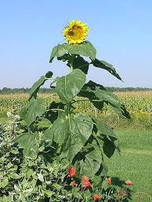](http://www.google.co.uk/url?sa=i&source=imgres&cd=&cad=rja&uact=8&ved=0CAwQjRwwAA&url=https://www.flickr.com/photos/chrisser/39208117&ei=-p1sVdfWH6PP7gbiq4HwCA&psig=AFQjCNHz4NPoaPUz-gKKlumA6PC3m73BeA&ust=1433268090605769)The plant could now be put into the ground.

If space is limited, a big pot will do, the bigger the better as sunflowers can get

top heavy. A cheap alternative is to use an old compost bag

(inside out looks better), a stack of old tyres, or basically any container

large enough. If you do not have access to outside space, I’m sure there are some

very willing relatives and friends who will help out, as in previous years!

**Taking it out of the pot and planting out.**

Simply make a hole the size of the sunflower’s pot in its new home’s compost/soil. To encourage growth, dig a bigger hole and fill with compost, home made or bought, first, then plant as below.

Carefully put your first two fingers around the base of the plant’s stem, over the pot compost, invert the pot and gently squeeze or shake the bottom. Hopefully the roots will hold the compost together as you then tip the plant back up and place the roots into their next home. Cover the roots up and fill any remaining hole. Try to avoid handling the plant too much as the stems and leaves snap easily.

Keep the plant well watered, and if possible well fed (There are so many ways to do this it really is a matter of personal choice). Tips on Sunflower growing can easily be found in various places.

If all has gone well, gradually over summer your plant will grow taller and stronger.

[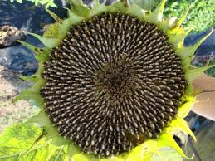](http://www.google.co.uk/imgres?imgurl=https://pickmeyard.files.wordpress.com/2010/05/sunflower-11.jpg&imgrefurl=http://imgarcade.com/1/sunflower-seed-growing/&h=336&w=448&tbnid=BQNbl8DdxCtbYM:&zoom=1&docid=gtWrykL8ifjjGM&hl=en&ei=CZ1sVd_LGNSQ7Abl4YMw&tbm=isch&ved=0CFIQMygoMCg)The stems can end up quite large. It will also need staking from an early stage to prevent it snapping in the wind. Alternatively growing it near a wall or fence makes it easier to support.

Hopefully eventually you should have at least one large flower.

**In the Autumn Term, watch for further information on next steps.**

**The community project is also hoping to have more information to come too.**

We are hoping enough will have survived that far to have competitions on height

and flower size.

The petals can be used in salads and cakes. Once it has flowered it will also provide you with edible seeds, safe and tasty to eat by themselves, baked or in salads etc. Some could be used to grow new plants next year. Or the large seed heads can be cut and left out for the birds to feed on.

**We would love to see the results of your efforts**. It could be the largest flower head, the tallest plant or more unusual locations/containers they are grown in. We know there are some very supportive relatives who helped out last year, what tips can they give this time? We would love to hear how your sunflower is getting on, so would welcome photos and news for the rest of this term and in the autumn.

[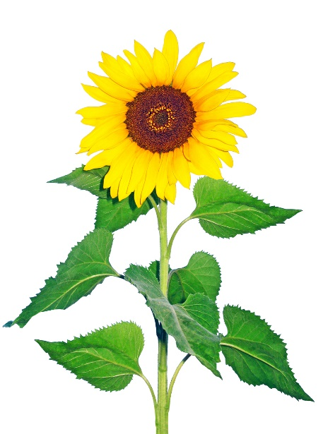](http://www.google.co.uk/url?sa=i&source=imgres&cd=&cad=rja&uact=8&ved=0CAwQjRwwAA&url=http://www.profitableplants.com/ten-most-profitable-cut-flowers-for-small-growers/&ei=EZ1sVbjAL4Kw7AaD7oKgCA&psig=AFQjCNGFz3uli9oJLxiT91LAxhffSlKoAA&ust=1433267857855146)If your sunflowers do not survive this far, don’t worry, hopefully you will have enjoyed taking part and learnt a little along the way. Everyone can watch and enjoy the progress of those grown around the school grounds, hopefully coming back in the new term to a colourful display.

Good luck and happy growing!