Louis Pearce – Y4P (Kingfishers) - Local history month
I am outside the barn at Edgewick farm, Woodland Way, Woburn Sands, this was a working farm delivering fresh milk in the village until 1959 and the barn was the cowshed used for milking the cows, it still has the stalls inside.

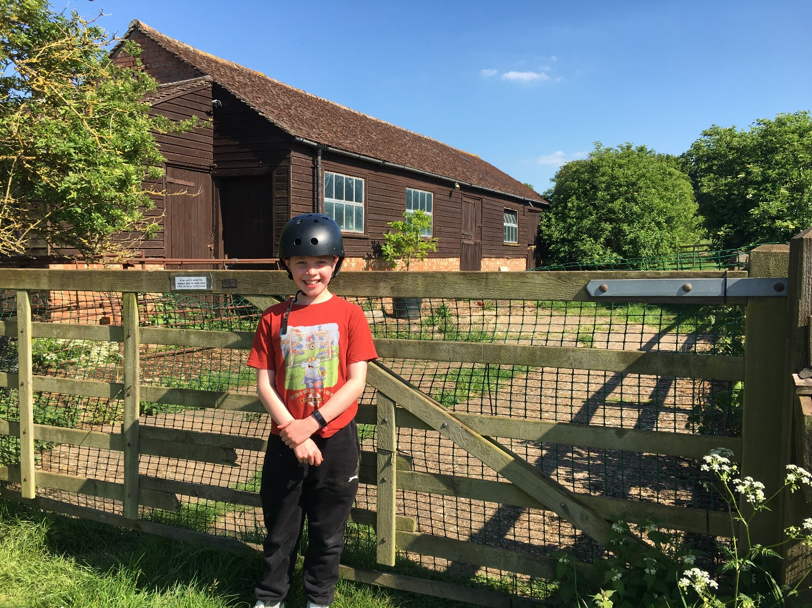
This is from the farm website and shows the old van that delivered milk.
