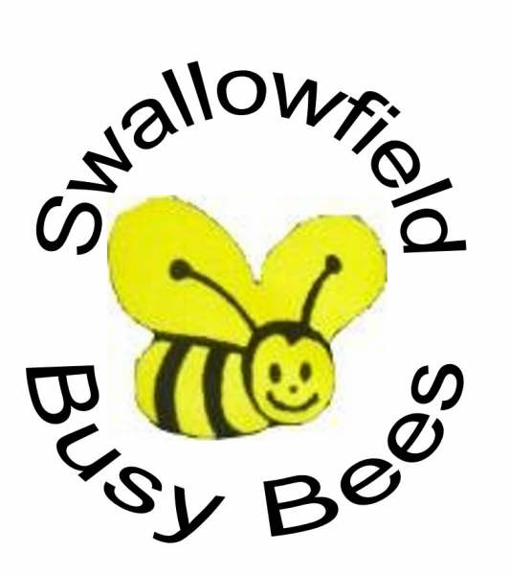  Activities you can try at home  The Busy Bees Team have been putting together a list of activities for you to try at home.  They are headed under the seven areas of the Early Years Foundation Stage  Most of these activities can be done at home and you will not need to buy any resources.  We have based them on what we know of your children’s likes and dislikes.  https://family.gonoodle.com/  https://www.bbc.co.uk/cbbc  https://www.purplemash.com/login/ | Personal, Social and Emotional Development  - Share stories with each other -retell them and act them out  - Make some bread or cakes together  - Encourage the children to help you with household jobs, help with washing up, fill the washing machine, gardening etc – make a list of jobs to do.  - Talk about your day at teatime.  - Prepare the family meal together.  - Role play / dressing up | Communication and Language  - Make sock puppets and use them to tell stories to each other.  - Have a singing session and sing action songs or nursery rhymes, organise a family talent show.  - Use household items to make your own musical instruments, pots, pans and spoons  - Play guessing games- think of an object and model giving clues to your child to help them guess an animal.  - Play some board games
 | Physical Development  - Water play – in the sink or at bath time, scooping, pouring.  - Play hide and seek with an object around the house  - Use the recycling to make some junk models  - Paint with water in the garden  - Build yourself a den with chairs and blankets.  - Large chalk pictures in the garden  - Make large circles in the air with scarves  - Cut some pictures from magazines using scissor  - Run, hop, jump and wriggle about for 10 mins every day. | Maths  - Help pair the socks in the washing basket  - Play snakes and ladders  - Play some bigger and smaller language games  - Sing numbers songs/look on Youtube.co.uk for number songs  - Sort things by colour or shape  - Make your own bowling game with toilet rolls and balls  - Count out carrots etc when preparing dinner  - Sort coins  - Watch Number blocks on cbbc
Literacy  - Share story books together- talk about what is happening, who are the characters in the story  - Play lotto games matching pictures and words  - Make a list of jobs to do  - Go to https://www.ruthmiskin.com to look at RWI videos  - Write letters in your name or draw a picture and talk about what you have drawn  - Play rhyming games | Understanding the World  - Blowing bubbles  - Make pizzas for the family  - Read information books or research on the internet about frogs, chicks, bugs  - Go on a bug hunt in your garden  - Freeze small toys – dinosaurs etc in ice and then investigate how to get them out  - Who is in your family? make a family tree  - Look at and talk about the different types of ICT in your home – microwave, phones, cooker, and remote controls.  - Keep an eye on your garden and count the birds you see or draw pictures of them in a book  - Set up a feeding station for the birds  - Plant some bulbs or seeds and look after them and watch them grow | Expressive Art and Design  - Have a good dance to some music  - Make a card for someone you know.  - Create a Go Noodle account for free  https://family.gonoodle.com/  - Sing familiar songs and make up your own words to nursery rhyme tunes  - Make props for your favourite story from things you have at home and act out the story together  - Make models from the junk at home  - Make your own musical instrument

